Geometry: Unit 7, Lesson 5
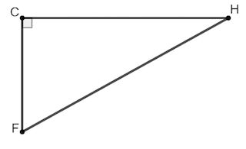
- $∆CHF$ shown is a right triangle. $\overline{CF}=5$ and $\overline{HF}=13$. What is the length of $\overline{CH}$?

$$12$$

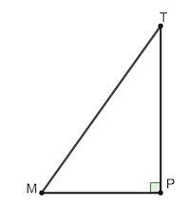
- In $∆TPM$, $m∠TPM=90°$, $\overline{TP}=7$, $\overline{MP}=24$ and $\overline{TM}=25$. What is the tangent of the angle $∠PTM$?

$$\frac{24}{7}$$

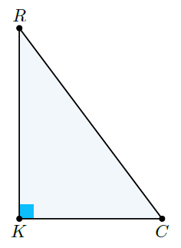
- Right triangle $∆RKC$ is shown where $KC=6$, $RK=8$, and $RC=10$. What is the tangent of $∠C$?

$$\frac{8}{6}$$

